Q1) John D. Newson, David F. Schwann, and Anne R. Ramoras all seem to be working on multiple projects, but they all reoccur in the data as certain different projects are listed.

Both Anne and David’s JOB_CHG_HOUR change with differing projects, which makes the data inconsistent and unreliable due to either update or insertion anomalies.

John’s EMP_PHONE has inconsistency because the last two digits of each entry are swapped from each other. This is likely a simple insertion anomaly.

Q2) Rather than making the first parameter of the data PROJ_NUM or PROJ_NAME, this data should become more concise and focus on EMP_NAMEs first, so that way they only need be mentioned in this table once.

Realizing that certain EMP_PHONE numbers are inconsistent, I’d insert the correct numbers wherever needed in the changed table.

Q3) Employees.txt, Projects.txt

Q4) A file holding all the employees’ specific information, and another file holding the projects and any corresponding information on those.

Q5a) In order: 1:M, 1:M, 1:1.

Each REGION “includes” many stores.

Each STORE “hires” many EMPLOYEEs.

Each EMPLOYEE “is assigned” one JOB.

Q5b) 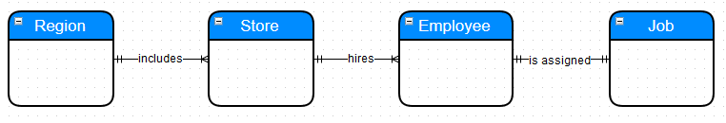

Q6a) A PATIENT “has” one doctor.

A PATIENT’s doctor can “make” one or many ORDERS for medications.

An ORDER can “include” one or many MEDICATIONs.

Q6b)



Q7a) A table for the GALLERY names to be stored, and then separate tables for each GALLERY, holding information about each PAINTER. Then, tables which link the PAINTERs to their PAINTINGs.

Q7b) Since every GALLERY has many PAINTINGs with many PAINTERs between them, every GALLERY’s relation to either set is one to many. The PAINTINGs, however, can only have one PAINTER. Because of that, the GALLERY table should link to the PAINTER table, and the PAINTER table should link to the PAINTING table in a one to many fashion.